We’d like to introduce a completely new ingredient for bread and pastries. Of course, we imagine that most customers in Japan are already familiar with this groundbreaking product.
That’s because nearly 20 years have passed since its development, and it has become a hot topic in the bread and pastry industry—ranging from small 30-gram packages for home use to bulk ingredients for commercial use on a scale of tens of metric tons.
If you search for “Chip Jam,” you’ll find a wealth of comments from avid users. Some customers have even gone so far as to upload videos to their websites or YouTube channels.

When “Chip Jam” is kneaded into bread or pastry dough and baked, it transforms into a jam-like consistency.
The principle is very simple: it uses the steam generated during baking to create the jam. It’s a groundbreaking, patented product that utilizes steam that would otherwise be wasted.
Some customers even use this principle to make processed products like sausages and mochi, as well as flavored popcorn.
At hotel breakfast restaurants, where pancakes are cooked in front of guests as part of the show, using Maple Chip Jam can even create long lines of customers.

The product has a three-year shelf life at room temperature when unopened, so it poses no burden to customers. It is a product well-suited for export. Since it is a sugar-processed product with a lower water activity value, bacterial growth does not occur. To be honest, we’ve had absolutely no issues even with products that are 10 years old. Furthermore, since the product is made to be very hard, the contents remain completely intact even if handled a bit roughly.

Additionally, because it is made using natural ingredients, it is a very safe product.
We do not use any preservatives or anti-microbial agents whatsoever. While incorporating fresh fruit into baked goods inevitably leads to problems such as spoilage or mold, with our chip jam, you can safely enjoy a variety of flavors.

In addition to bread, pastries, and muffins, we also offer a product called “Toppings,” developed specifically for use in chocolate and ice cream that do not require heating.
In addition to common flavors such as blueberry, strawberry, maple syrup, and honey, we also carry Japanese-original flavors like yuzu, matcha, and sakura. We also offer flavors popular with European customers, such as cinnamon, raspberry, espresso, and chocolate. Furthermore, if you wish, we can assist you in developing original chips exclusive to your company.

By adding a small amount of these chips to your company’s signature dough, you can create unique products with a distinctive flavor unlike anything before. Please try this innovative ingredient that delivers on all three fronts: “Fun to make, fun to sell, and fun to eat!!”

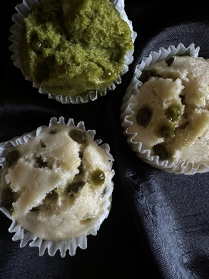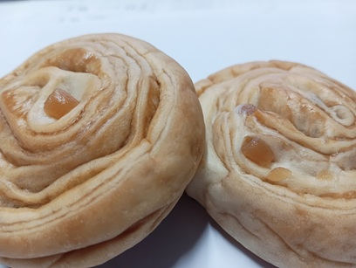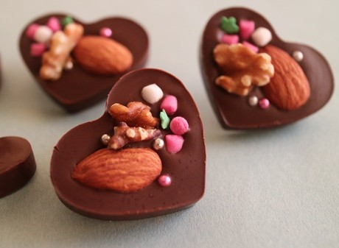
Mattcha Maple-syrup For Chocolate
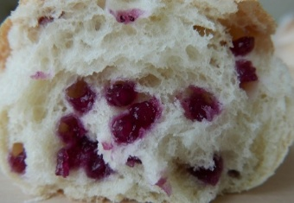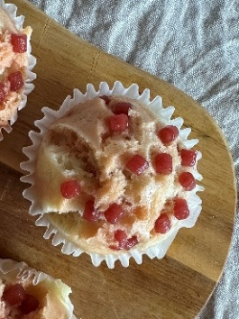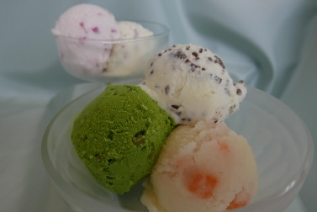
Blueberry Strawberry For Ice cream

